# **Shangry:Users:shang:Desktop:UPCOMING 2014:*PHOTOS AND E-PROMOS:SHANG-LOGOS VARIOUS 2014:COOL GRIMEY HAT.jpg**

# **1.8 MILLION EMAILS SIGNED UP THROUGH OFFICIAL WEBSITE**

# [**HTTP://WWW.IAMSHANG.COM**](HTTP://WWW.IAMSHANG.COM)

SHANG, a transplanted New Yorker whose carefully   
nurtured evolution from stand-up comedy to socio-political satire gives heavy flight to the spoken and outspoken word. The Famecast Comedy Winner, SHANG has been seen on CBS’S THE LATE LATE SHOW,  2 BET'S COMIC VIEW SPECIALS,  STARZ 1ST AMENDMENT, ABC’S COMIC’S UNLEASHED, NBC’S “HEROES”, CBS’S “CSI” “NCIS” QUE’ LOCOS, & COMEDY CENTRAL. Also coming in 2018 you can see him on the new show “Kamkazee Comedy” On FUELTV & GOTHAM COMEDY LIVE On AXS TV.

With **1.8 million** email sign ups &  **3.2 Million**   
followers through **All** social media Platforms.

# UPDATED%20RESUME%202020%20(1).jpg

# SOCIAL MEDIA OUTREACH COMEDIAN SHANG



**Twitter 189,000**



**Facebook 88,980  
  
**

**Black Planet 635,500**



**Instagram 47,00 /   
Video vIews 1,600,000**



**Youtube 981,000**

 **Migente 50,000**

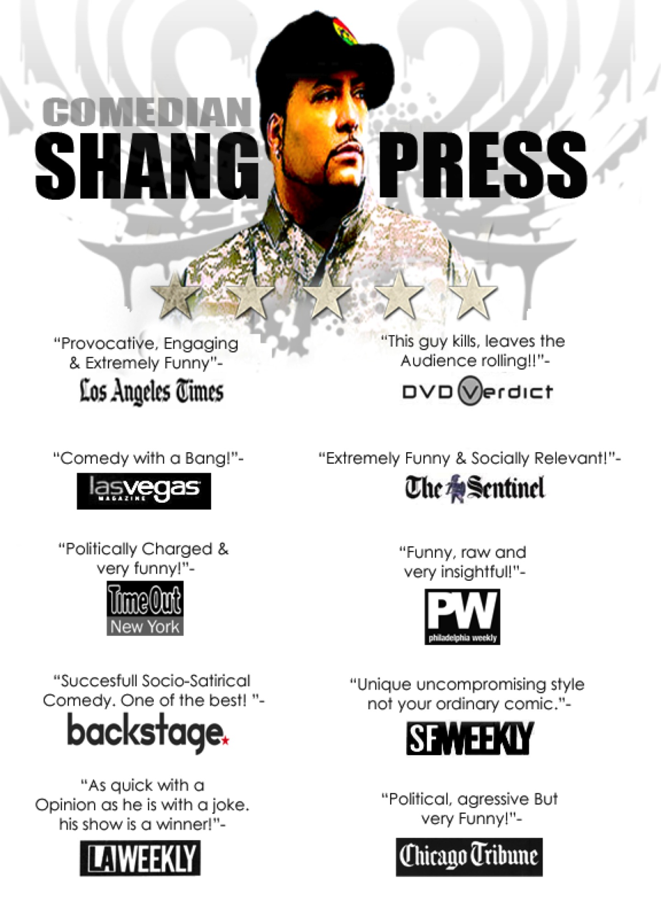

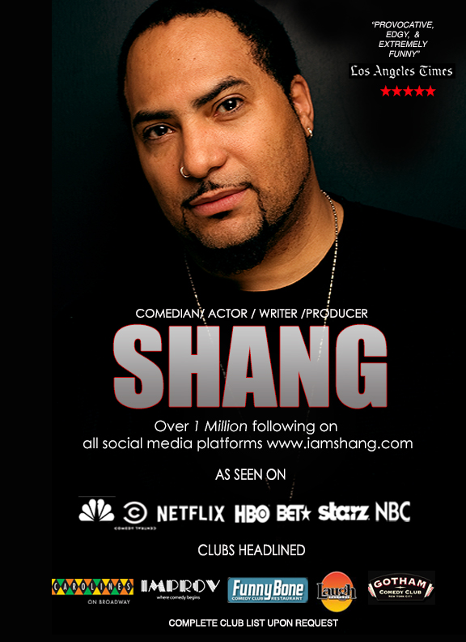

**FOR INFO & THE & MEDIA NO.S :DARK AS LIGHT PRODUCTIONS-   
OFFICE 323-498-0289 CEL-213-447-0599**[shangism@pacbell.net](mailto:shangism@pacbell.net)